KASBAH Membership Renewal Form 2020 – 2021

Please note that there is a voluntary membership fee of *£6.00 -
any contribution that you can afford is appreciated, cheques to be made payable to KASBAH (or ring the office for online bank details), or via paypal – admin@kasbah.org.uk

Please complete this form and return to the KASBAH office, email or hand to a member of staff.

Member name……………………………………………………………………………

Contact/parent/carer name (if different)……………………………………………..

Address…………………………………………………………………………………..

……………………..…………….…… Post Code………………………………….

Phone No(s):-………………………. Mobile No …………………………………

Are you willing to receive KASBAH correspondence by email? Yes / No

Email address…………………………………………………………………………..

Do you/your child have any of the following (please circle):
Hydrocephalus / Spina Bifida / Spina Bifida & Hydrocephalus /
Spina Bifida Occulta / Learning disability

Other condition(s)…………………………………………....

Living Status: ………………………………………………………………………….
(i.e. With parents/independently/residential)

Date of Birth of person with condition(s): ………………………….

Parents Names (If applicable): Mother:…………………Father:………………………………

Do you wish for the advisor to contact you? Yes / No

Best number to contact you on…………………………………………………………………

I give consent for KASBAH to hold a record of my/and/or my child’s personal details on the KASBAH membership database and paper files.

All information will be held indefinitely or until such a time deemed appropriate, or it is requested by the member/carer to destroy the file(s). Please note, in compliance with the Data Protection Act 1998, no such details would be released to any third party.

Signed………………………………………………. Date………………………………………….

*Please complete the reverse Gift Aid information if you currently pay income tax.

Gift Aid declaration
Name of charity : KASBAH

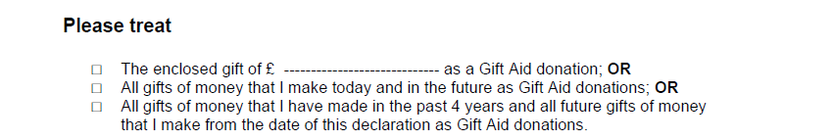
Please tick the appropriate box
You must pay an amount of Income Tax and/or Capital Gains Tax for each tax year (6 April one year to 5 April the next) that is at least equal to the amount of tax that the charity or Community Amateur Sports Club will reclaim on your gifts for that tax year.
Donor’s details
Title --------- Initial(s) ------------ Surname ----------------------------------------------------------

Home address -------------------------------------------------------------------------------------------

----------------------------------------------------------------------------------------------------------------

Postcode ---------------------------------- Date --------------------------------------------------------

Signature ----------------------------------------------------------------
Please notify the charity if you:

Want to cancel this declaration

Change your name or home address

No longer pay sufficient tax on your income and/or capital gains.

Tax claimed by the charity or CASC
• The charity or CASC will reclaim 28p of tax on every £1 you gave up to 5 April 2008.
• The charity or CASC will reclaim 25p of tax on every £1 you give on or after 6 April 2008.
• The Government will pay to the charity or CASC an additional 3p on every £1 you give between 6 April 2008 and 5 April 2011. This transitional relief for the charity or CASC does not affect your personal tax position.

If you pay Income Tax at the higher rate, you must include all your Gift Aid donations on your Self Assessment tax return if you want to receive the additional tax relief due to you.

